

user DOCUMENTATION

Ag Inspection Tool – Plant Pest and Other Inspections

Prepared for: Solano County, California
Department of Information Technology

Prepared by: KCI Technologies, Inc.

Table of Contents
Table of Contents 2
Document Control 3
Overview 4
GIS Portal Content Links 4
Launching the Plant Pest and Other Field Map and web Application 5
Field Maps 5
GIS Portal 5
Manage Data using the Field Maps Mobile Application 5
Add Inspection Points (PPO) or Address Point Features 5
Add Plant Pest and Other Inspections Record 6
Edit Plant Pest and Other Inspections Record 7
Delete Plant Pest and Other Inspections Record 8
Web Map and Application Content Details 8
Map Data 8
Web Application Widgets 8
Using the Edit Widget 9
Create an Inspection Point (PPO) or Address Point Feature 9
Add Plant Pest and Other Inspection Records to the Inspection Point (PPO) or Address Point Feature 9
Edit an Inspection Point (PPO) or Address Point Feature 10
Delete an Inspection Point (PPO) or Address Point Feature 10
View and Edit Attachments on Plant Pest and Other Inspection Records 11
View Photo/Image/File Attachments 11
Add Photo/Image and File Attachments 11
Delete Photo/Image and File Attachments 12
Using the Query Widget 13
Database Views 13

Document Control
Version | Date | Purpose / Action | Author
1.0 | 12/18/2023 | Document created | Andrew Blowers

Overview

The Agriculture Department and GIS staff collaborated to develop the “Ag Inspection Tool,” which initially contains Incoming Shipment Tracking, Plant, Pest and Other Inspections, and PQ Inspection Tracking components. As development progressed, the team determined that the application would need to split into separate groups and Portal content (Feature Services, Web Maps, and Web Applications) to handle user access. The “tool” was divided into one group for the Incoming Shipment Tracking and Plant, Pest, and Other Inspection and another for the PQ Inspection Tracking. This document is specifically for the Plant, Pest, and Other components.

The field and web workflows support inspections for various plants, pests, and “other,” being the Resident Complaint/CDFA/County Follow Up inspection type. Records are stored in a related table off the “Address Points” feature pulled from the SC Prime database, and an “Inspection Point” feature class created for situations where an inspection is performed where an address is not available. Each record will relate to one inspection or address point feature and be updated until complete. In short, only one record should exist for a given inspection. The relationship between both feature classes is one-to-many to the Plant Pest and Other Inspections related table. Database views have been configured to ease the display of the related records in both the field map and web application. Note that these view layers are not editable.

The supporting content for this application includes a field web map for use in Esri’s Field Maps mobile application and an “editing” application built using Esri’s Web AppBuilder. The web map is configured to allow users to select an address point within the County’s “Address Points” layer and create a related record in the Plant Pest and Other Inspections table. The field map also includes an “inspection point” feature where users can add a point to the map that does not relate to an address but adds a record to the same related table. The intended use of the web application is to provide a workflow for all users to monitor progress, perform specific edits, create plant, pest, and other inspection records from a desktop/laptop computer, and view/upload/edit attachments.

Stakeholders: Agriculture Department
Point of Contact: Matthew Carl

GIS Portal Content Links
- Group – Incoming Shipments and PPO Inspections
  - https://solanocountygis.com/portal/home/group.html?id=325f3033823a4b46a69207c5cb20e58d#overview
- Field Map – Plant Pest Other Insp – Field Map
  - https://solanocountygis.com/portal/home/item.html?id=97652afc76f2480eaa9fabc05764feed
- Web Application – Plant Pest Other Insp Web App
  - https://solanocountygis.com/portal/home/item.html?id=24f20646bd814e2c97848927c473260f

Launching the Plant Pest and Other Field Map and web Application

Field Maps
The “Plant Pest Other Insp – Field Map” is accessible in Esri’s Field Maps mobile application. Esri’s Field Maps application is available via app stores on Android and iOS devices. Survey123 is available on desktop/laptop computers from Esri’s Survey123 resources page or the Microsoft Store.

- Launch Esri’s Field Maps application on a mobile device or tablet.
- Search for the “Plant Pest Other Insp – Field Map” web map or open the “Incoming Shipment Tracking and PPO Inspections” group, then select the map. The map will load to the default extent, the last extent the user was viewing the map, or pin-pointed to the devices’ location (if-onsite and available)

GIS Portal
- Login into the GIS Portal
  - Users can also navigate directly to the application using this URL - https://solanocountygis.com/portal/home/item.html?id=24f20646bd814e2c97848927c473260f
- Once logged into the Portal, select the Groups tab at the top of the webpage.
- Search for or navigate to the Incoming Shipments and PPO Inspections group. Open the group.
- Select the Content subtab and open the “Plant Pest Other Insp Web App” Web Mapping Application.
- Select the View Application button to launch the web application.

Manage Data using the Field Maps Mobile Application

Add Inspection Points (PPO) or Address Point Features
- Follow the steps in the “Launching the Plant Pest and Other Field Map and Web Application” Field Maps section.
- Once the map loads, use the device’s location (if on-site and available) or the search to locate an address point or existing inspection point.
- Select the Plus (“Crosshair”) button in the bottom right-hand corner of the application.
- Drag the crosshair in the center of the application to the desired location. “Pinch” the screen to zoom in or out on the map.
  - Field Maps should start the crosshair on the device’s current location if the mobile device has GPS capabilities and the application has the correct permission settings. If the location needs to be modified, follow steps 5 and 6 below.
- Choose between the Inspection Points (PPO) feature templates or the Address Points. Tap the feature to select it.
- To update the point location, move the crosshair to a new location, then select the Update Point button.
- Populate the necessary or required attributes for the feature
  - Note that the “Inspection Type” attribute defaults to “Plant Pest & Other Inspection,” and the “Inspection Status” attribute is preset based on what was chosen in the Edit widget for the inspection points.
  - Note that there are required fields for the Address Point. These fields can be populated with placeholder data and reviewed later in the office or when the feature is compared to the SC_Prime database feature class.
- Select Submit in the upper right-hand corner of the application.
- To cancel the new feature, select Cancel in the upper left-hand corner of the application.
- Following the successful submission of a new feature, the point should remain selected in the attribute pane at the bottom of the screen. Follow the steps in the Add Inspection Points (PPO) or Address Point Features section of the document below, starting with bullet #4.

Add Plant Pest and Other Inspections Record
- Follow the steps in the “Launching the Plant Pest and Other Field Map and Web Application” Field Maps section.
- Once the map loads, use the device’s location (if on-site and available) or the search to locate an address point or existing inspection point.
  - The address points are searchable by the contents of the “Full Address” field or “APN” field. The inspection point features are searchable by the contents of the address entered on the point.
- Select the existing address point or inspection point by tapping it on the screen to open the attribute pane at the bottom of the application.
  - In areas where numerous features are present, the application may present several options across multiple layers to choose from.
- Tap the Link icon or scroll to the bottom of the table and select the Plant Pest and Other Inspections related table.

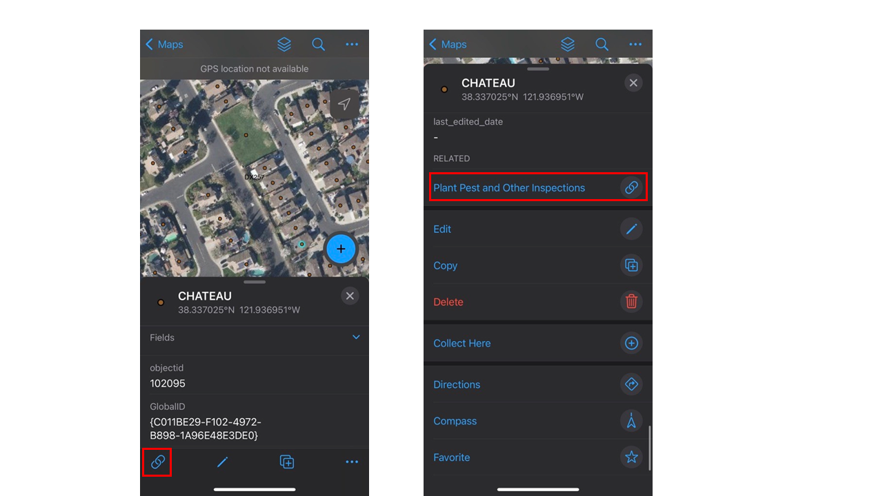
*Note – Application appearance may vary depending on the device being used
- Tap the Add button to create a new record in the related table

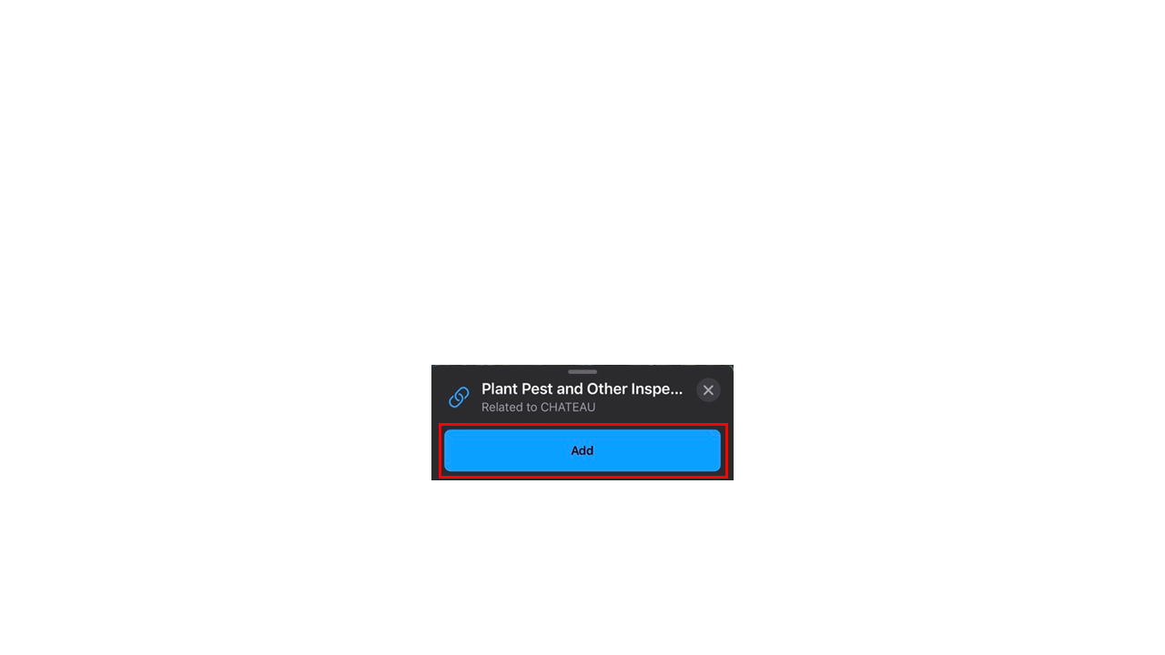
- Populate the attributes provided in the attribute pane at the bottom of the application and provide any attachments.
  - Use the Take Photo button at the top of the attribute values to take a photo(s) using the device’s camera. Use the Attach button to add existing photos stored on the device or documents such as a .docx or .pdf file.
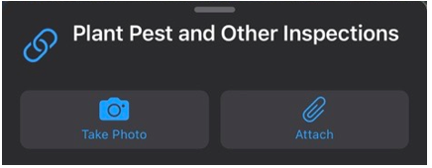

Edit Plant Pest and Other Inspections Record
- Follow the steps in the “Launching the Plant Pest and Other Field Map and Web Application” Field Maps section.
- Once the map loads, use the device’s location (if on-site and available) or the search to locate an address point or existing inspection point.
  - The address points are searchable by the contents of the “Full Address” field or “APN” field. The inspection point features are searchable by the contents of the address entered on the point.
- Select the existing address point or inspection point by tapping it on the screen to open the attribute pane at the bottom of the application.
  - In areas where numerous features are present, the application may present several options across multiple layers to choose from.
- Select the Link icon or scroll to the bottom of the table and select the Plant Pest and Other Inspections related table.
- Select an existing Plant Pest and Other Inspection record from the list to open it in the attribute pane.
- Select the Pencil icon or scroll to the bottom of the pop-up and select Edit.

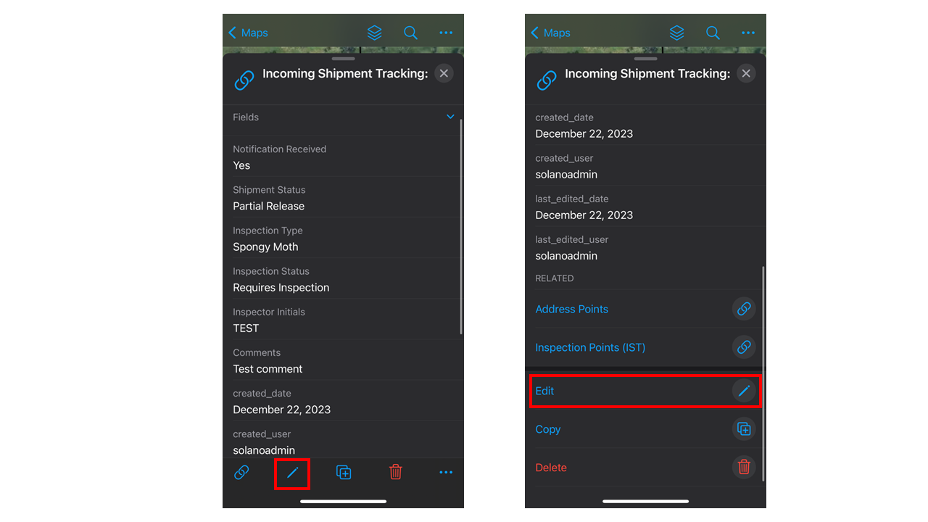

Delete Plant Pest and Other Inspections Record
- Follow the steps in the “Launching the Plant Pest and Other Field Map and Web Application” Field Maps section.
- Once the map loads, use the device’s location (if on-site and available) or the search to locate an address point or existing inspection point.
  - The address points are searchable by the contents of the “Full Address” field or “APN” field. The inspection point features are searchable by the contents of the address entered on the point.
- Select the existing address point or inspection point by tapping it on the screen to open the attribute pane at the bottom of the application.
  - In areas where numerous features are present, the application may present several options across multiple layers to choose from.
- Select the Link icon or scroll to the bottom of the table and select the Plant Pest and Other Inspections related table.
- Select an existing Plant Pest and Other Inspections record from the list to open it in the attribute pane.
- Select the Trash Can button or scroll to the bottom of the pop-up and select Delete.
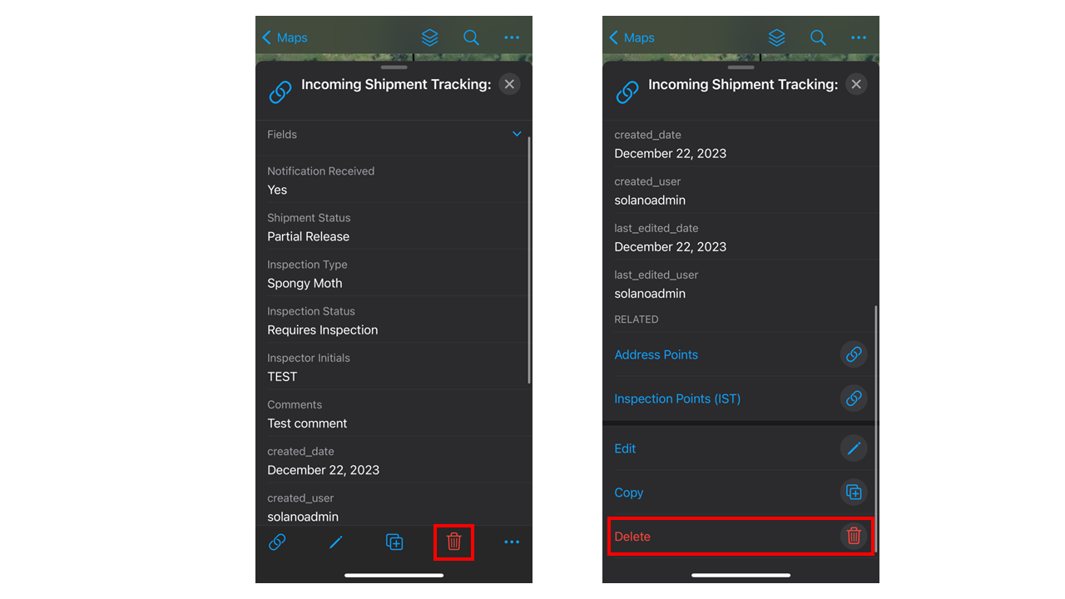

- Confirm the deletion by selecting Delete on the confirmation prompt or Cancel to cancel the deletion of the Plant Pest and Other Inspections record.

Web Map and Application Content Details

Map Data
- GWSS Trap Grids
- Inspection Points (PPO)
- Address Points
- PPS IP PlantPestOther Inspections (View) (visibility off by default)
- PPS PlantPestOther Inspections (View) (visibility off by default)
- County Boundary
- Plant Pest and Other Inspections (data table)

Web Application Widgets
- Search Widget – allows the user to search by place, address (Esri Geocoder or Inspection Point (PPO) feature, Full Address, or APN.
- Select Widget – allows the user to select visible features using a point or rectangle. The selection can be viewed in the attribute table. Double-click a record in the attribute table to open the pop-up.
- Edit Widget – allows the user to create or edit “Inspection Points (PPO)” points and Address Points and create or edit Plant Pest and Other Inspection-related records. Users can also view and modify attachments.
- Query Widget - allows the user to run queries against features in the web map backing the web application. The queries are specified in the widget but provide various options for each feature.
- Legend Widget – shows feature symbology for layers turned on in the Layer List widget.
- Layer List Widget – allows users to toggle layers in the map on/off and adjust visual options.
- Basemap Gallery Widget – allows users to change the current basemap shown in the application. The Widget utilizes the Portal’s basemap gallery.
- Bookmarks Widget – allows users to view bookmarks saved in the web map or add bookmarks specific to the web mapping application.
- Legend widget – displays the selected layers within the legend.
- Basemap widget – includes 11 different basemap options.

Using the Edit Widget
The “Plant Pest and Other Inspection” web application includes the edit widget to allow users to view/create/edit inspection point features, Address Points, Plant Pest and Other Inspection records, and attachments. The undo/redo feature is available in the Edit widget pane to revert and reapply changes in order.

Create an Inspection Point (PPO) or Address Point Feature
- Select the Edit widget (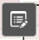) below the search bar in the upper left corner of the application.
- Select one of the three Inspection Points (PPO) feature templates or the Address Point.
  - Note that three options for the inspection points are available based on the feature’s symbology. Generally speaking, users should select the “Active” option.
  - Note that the widget will display a “permissions” error if the map is not zoomed into the visible scale range for the inspection and address point features.
- Using the mouse, move the cursor over the desired location for the point feature and left-click on the map to place it. Release the left mouse button to place the point feature.
  - To move the feature
    - Hover over the point until the mouse arrow changes to the pointer finger cursor.
    - Click and drag to the new location.
    - Release the left mouse button to place the point feature
- Populate the necessary attributes in the pop-up using free text, the calendar (date fields), or dropdowns.
  - Note that the “Inspection Type” attribute defaults to “Plant Pest & Other Inspection,” and the “Inspection Status” attribute is preset based on what was chosen in the Edit widget for the inspection points.
  - Note that there are required fields for the Address Point. These fields can be populated with placeholder data and reviewed later in the office or when the feature is compared to the SC_Prime database feature class.
- Scroll to the bottom of the pop-up and click the Close button.
  - Note that edits are saved automatically.

Add Plant Pest and Other Inspection Records to the Inspection Point (PPO) or Address Point Feature
- Once the map loads, locate an address point with the plus/minus buttons or scroll wheel. Users can also use the search widget to find the address (Full Address) or APN from the Address Points feature or the address added to an existing Inspection Point feature.
- Click within the address point to open the pop-up.
- Scroll to the bottom of the pop-up and select the Plant Pest and Other Inspection-related table.
- Select the ellipsis (…) button in the lower right-hand corner of the pop-up.
- Select Edit from the menu.
- Click the Plus sign in the upper right-hand corner of the pop-up
- Populate the necessary attribute and attach any files following the steps in the Add Photo/Image and File Attachments section.
- Click the Save button.
- If edits and attachments are complete, click the Close button to close the pop-up.
- To delete the related record, click the Delete button.
  - Note that the edit widget deletes the record without confirmation and cannot be undone.

Edit an Inspection Point (PPO) or Address Point Feature
There are two ways to open the editing pop-up for these features:
- Edit Widget
  - Select the Edit widget below the search bar in the upper left corner of the application.
  - Select the existing inspection or address point on the map using a left click on the mouse.
  - The editing pop-up will open next to the selected point feature
  - Update the necessary attributes and either scroll to the bottom of the pop-up and click the Close button or click the X button in the upper right corner of the pop-up.
    - Note that edits are saved automatically.
- Pop-up
  - Select the inspection or address point that requires edits to open the pop-up.
  - Select the ellipsis (…) button in the lower right-hand corner of the pop-up.
  - Select Edit from the menu.
  - The editing pop-up will open next to the selected point feature
  - Update the necessary attributes and either scroll to the bottom of the pop-up and click the Close button or click the X button in the upper right corner of the pop-up.
    - Note that edits are saved automatically.

Delete an Inspection Point (PPO) or Address Point Feature
There are two ways to open the editing pop-up to delete a feature.
- Edit Widget
  - Select the Edit widget below the search bar in the upper left corner of the application.
  - Select the existing inspection point on the map using a left click on the mouse.
  - The editing pop-up will open next to the selected point feature
  - Scroll to the bottom of the pop-up and click the Delete button.
    - Note that edits are saved automatically, and the pop-up will close.
- Pop-up
  - Select the inspection point that requires edits to open the pop-up.
  - Select the ellipsis (…) button in the lower right-hand corner of the pop-up.
  - Select Edit from the menu.
  - The editing pop-up will open next to the selected point feature
  - Scroll to the bottom of the pop-up and click the Delete button.
    - Note that edits are saved automatically, and the pop-up will close.

View and Edit Attachments on Plant Pest and Other Inspection Records
Attachments can be viewed and edited (deleted) using the web application. Note that the screenshots below are from the development application to avoid editing or deleting attachments on production data.

View Photo/Image/File Attachments
- Select an Inspection Points (PPO) or Address Point feature on the map.
- Scroll to the bottom of the pop-up and select Plant Pest and Other Inspections below the Related Tables header.
- Select the desired Plant Pest and Other Inspection record from the list.
- The related record will appear in the pop-up.
- Scroll to the bottom of the pop-up and select a hyperlink under the “Attachments” header text for the attachment to view.
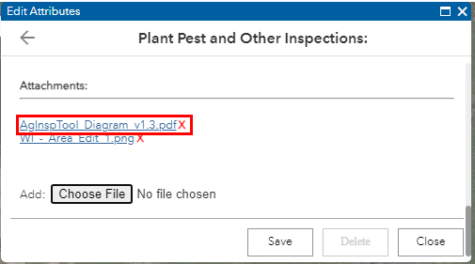
- The attachment will open in a new browser tab.

Add Photo/Image and File Attachments
There are two ways to open the editing pop-up for an Inspection Points (PPO) or Address Point feature and add attachments:
- Edit Widget
  - Select the Edit widget below the search bar in the upper left corner of the application.
  - Select an Inspection Points (PPO) or Address Point feature on the map.
  - Scroll to the bottom of the pop-up and select Plant Pest and Other Inspections below the Related Tables header.
  - Select the desired Plant Pest and Other Inspections record from the list.
  - The related record will appear in the pop-up.
  - Scroll to the bottom of the pop-up and select a hyperlink under the “Attachments” header text for the attachment to view.
  - Click the Choose File button, navigate to the file using the Windows file explorer, and click the Open button. The file will attach automatically.
  - Select the back arrow in the upper left corner of the pop-up to return to the Plant Pest and Other Inspection-related records list or the Close button to exit the pop-up window.
  - Click on the map next to the point to deselect the feature.

- Pop-up
  - Select an Inspection Points (PPO) or Address Point feature on the map to open the pop-up.
  - Select the ellipsis (…) button in the lower right-hand corner of the pop-up.
  - Select Edit from the menu.
  - Scroll to the bottom of the pop-up and select Plant Pest and Other Inspections below the Related Tables header.
  - Select the desired Plant Pest and Other Inspections record from the list.
  - The related record will appear in the pop-up.
  - Scroll to the bottom of the editing pop-up until the “Attachments” header text is visible.
  - Click the Choose File button, navigate to the file using the Windows file explorer, and click the Open button. The file will attach automatically.
  - Select the back arrow in the upper left corner of the pop-up to return to the Plant Pest and Other Inspection-related records list or the Close button to exit the pop-up window.
  - Click on the map next to the point to deselect the feature.

Delete Photo/Image and File Attachments
There are two ways to open the editing pop-up for an inspection or address point and delete attachments:
- Edit Widget
  - Select the Edit widget below the search bar in the upper left corner of the application.
  - Select an Inspection Points (PPO) or Address Point feature on the map.
  - Scroll to the bottom of the pop-up and select Plant Pest and Other Inspections below the Related Tables header.
  - Select the desired Plant Pest and Other Inspections record from the list.
  - The related record will appear in the pop-up.
  - Click the small red X to the right of the file hyperlink to delete the attachment.
    - Note that the delete can not be undone using the Edit widget.

- Pop-up
  - Select the Inspection Points (PPO) or Address point on the map to open the pop-up.
  - Select the ellipsis (…) button in the lower right-hand corner of the pop-up.
  - Select Edit from the menu.
  - The editing pop-up will open next to the selected point feature.
  - Scroll to the bottom of the editing pop-up until the “Attachments” header text is visible.
  - Click the small red X to the right of the file hyperlink to delete the attachment.
    - Note that the delete can not be undone using the Edit widget.

Using the Query Widget
The “Plant Pest and Other Inspection” web application includes the query widget to allow users another method for searching the features and related tables included in the web map backing the web mapping application.
- Select the Query widget () below the search bar in the upper left corner of the application.
- The widget will select the Tasks tab by default and display the queries available to the user.
- Select one of the tasks within the tab to display the available parameters and enter values as needed:
  - Inspection Points (PPO)
    - Address (contains)
    - Inspection Type (is)
      - The Inspection Type option will display a drop-down that matches the possible values for the symbology.
  - Address Points
    - APN (contains)
    - Full Address (contains)
  - PPS IP PlantPestOther Inspections (View)
    - Inspection Type (is)
    - Address (contains) (Inspection Points “Address” field)
    - PPO Inspection Type (is)
  - PPS PlantPestOtherInspections (View)
    - Full Address (contains)
    - APN (contains)
    - Inspection Type (is)
- Click the Apply button.
- The widget will switch to the Results tab once the query has finished running against the selected feature.
- Select a result in the query widget to pan/zoom the map to the approximate location of the feature.
- On the map, select (click) the feature underlying the “result” layer from the query widget to present the correct pop-up.
- If necessary, return to the Tasks tab and either rerun the query or select the back arrow in the upper-left-hand corner of the widget (below “Tasks”) to select another query.
- To remove the “results” layer from the map, close the widget in the upper right-hand corner of the widget.

Database Views
The database views created for the Plant Pest and Other Inspections portion of the “Ag Inspection Tool” combine an Inspection Point (PPO) or Address Point feature with its related Plant Pest and Other Inspections Record. These features are symbolized to provide as much detail as possible from the status and type values. The views are non-editable but update dynamically based on changes to the point feature or related records.

